TO: Jeff Studenka, Permit Writer

FROM: Chris Bittner, Standards Coordinator

DATE: July 8, 2019

SUBJECT: Wasteload Analysis & Antidegradation Reviews for the Salt Lake City Water
Reclamation Facility, 2019 UDPES Permit No. UT0021725

RECEIVING WATERS AND STREAM CLASSIFICATION
The discharge is to the Oil Drain Canal, then to the Salt Lake City Sewage Canal and then into Farmington Bay of the Great Salt Lake. According to the Utah Administrative Code (UAC) R317-2-13, the Oil Drain Canal and Salt Lake City Sewage Canal are classified as 2B and 3E and the Great Salt Lake is classified as 5.

Class 2B Protected for infrequent primary and secondary contact recreation.
Class 3E Severely habitat-limited waters. Narrative standards will be applied to protect these waters for aquatic wildlife.
Class 5D Farmington Bay of the Great Salt Lake. Protected for infrequent primary and secondary contact recreation, waterfowl, shore birds and other water-oriented wildlife including their necessary food chain.

BASIS FOR EFFLUENT LIMITATIONS
Limitations on total suspended solids (TSS), biochemical oxygen demand (BOD₅), E. coli, pH and percent removal for BOD₅ and TSS are based on current Utah Secondary Treatment Standards, UAC R317-1-3.2. The DWQ has determined that this discharge will not cause or contribute to a violation of water quality standards based upon the Reasonable Potential Analysis and Level 1 Review that follows. An Antidegradation Level II Review is not required since water quality will not be further lowered by the proposed activity, UAC R317-2-3.5.b.1.(b).

Numeric criteria are available for pH, E. coli and turbidity for the recreational use in the Northwest Oil Drain (NWOD). However, no numeric criteria are available for the aquatic life uses in the NWOD or Farmington Bay. The Level I Antidegradation Review, protection of existing uses, was conducted in accordance with the Interim Methods for Evaluating Use Support for Great Salt Lake Utah Pollution Discharge Elimination System (UPDES) Permits (v. 1.0 January 4, 2016) (Interim Methods). No existing uses are identified that require more stringent protection than the designated uses.

As described in the Interim Methods, effluent pollutant concentrations were screened against Class 3D aquatic life numeric criteria to determine reasonable potential and the protection of the uses. Based on application of Narrative Standards, acute criteria were screening values for the NWOD and chronic criteria were used at Farmington Bay under the Narrative Standards.

The previous permit required monitoring in the NWOD. The purpose of this investigation was to decrease uncertainties regarding selenium, ammonia, and dilution. The results of this monitoring are documented in the Northwest Oil Drain and Salt Lake Sewage Canal Selenium, Ammonia and Flow Characterization Report (Stantec, May 10, 2018) (NWOD Report). Figure 1 illustrates the monitoring locations and Figure 2 summarizes the results as presented in the NWOD Report.

Significant Updates compared to 2014 permit.

Selenium
Based on the findings of the NWOD Report, selenium was determined to not have reasonable potential. Selenium concentrations from all sources to the NWOD at the Farmington Bay were approximately 25% of the selenium chronic criterion (Figures 2 and 3). No other pollutants, except for ammonia, have reasonable potential.

Ammonia.
As reported in the NWOD Report, ammonia concentrations were measured at several locations on the NWOD during the previous permit cycle (Figure 3). These ammonia concentrations represent all sources of ammonia to the NWOD. For this permit cycle, the updated 2013 EPA ammonia criteria were used for screening because these criteria better represent the potential for ammonia toxicity for the aquatic life expected at this location. The 2013 EPA chronic criteria applied are based on an absence of salmonids (trout) and unionid mussels in the receiving waters.

Ammonia concentrations measured at the discharge to Farmington Bay compared to the chronic screening criteria are shown on Figure 4. Ammonia concentrations exceed the screening values and were further investigated for reasonable potential.

The representativeness of the 2013 EPA ammonia criteria was evaluated in more detail. This evaluation concluded that these are appropriate screening values for determining effluent limits for the discharge to Farmington Bay. Ammonia is generally toxic to aquatic life but species vary widely in their sensitivity. Ammonia is also a nutrient that is taken up rapidly by plants and bacteria when present at sub-toxic concentrations. Farmington Bay includes freshwater taxa such as daphnids and mayflies. Fish can be sensitive to ammonia and fish have been observed in Farmington Bay and surrounding wetlands. Fish are observed in similar freshwater habitats at Great Salt Lake and fish presence in nearby waters such as waterfowl management areas and observations of fish-eating birds support that fish should be considered residents for the comparison criteria. Studies are ongoing to better characterize fish populations in Farmington Bay. For this permit cycle, early life-stages of fish were presumed to be absent for the winter months similar to the lower Jordan River.

The ammonia loads to Farmington Bay are compared to the ammonia loads discharged from the SLCWRF and the Chevron Refinery in Figure 5. The Chevron Refinery’s portions of the ammonia loads to the NWOD add up to 5 percent to the SLCWRF loads. Ammonia loads to Farmington Bay generally correlate well with the loads from the SLCWRF

Consistent with Utah Wasteload Analysis procedures, acute limits are based on the maximum observed pH and temperature of the effluent [note: ammonia limits are very sensitive to pH and to a lesser extent temperature]. Chronic limits are based on the average pH and temperature in the NWOD at the Farmington Bay discharge (Table 1) effluent [note: ammonia limits are very sensitive to pH and to a lesser extent temperature]. No mixing was considered for the comparisons to acute screening values because upstream flow contributions from e.g., Warm Springs, were unable to be measured. The chronic comparisons were based on the measurements made in the NWOD at the discharge to Farmington Bay. Table 2 shows the recommended effluent limit for ammonia to ensure protection of the aquatic life uses.

Table 1
Maximum Effluent Total Ammonia Nitrogen Concentrations (mg/L)
Season | Acute: one hour | Chronic: 4-day average
June through August | 18.3 | 5.9
September through November | 17.8 | 6.7
December through February | 17.8 | 11.8
March through May | 17.8 | 4.6

Table 2
pH and Temperature used for Total Ammonia Nitrogen Effluent Limits
Season | June-August | Sept.-Nov. | Dec.-Feb. | March-May
pH (acute) | 7.5 | 7.6 | 7.6 | 7.6
Temp. ℃ (acute) | 23.7 | 21.4 | 14.5 | 19.0
pH (chronic) | 6.8 | 6.9 | 7.3 | 7.5
Temp ℃ (chronic) | 23.6 | 14.7 | 9.8 | 15.4

Whole Effluent Toxicity (WET) Testing
One of the objectives of the monitoring described in the NWOD Report was to measure flows in the NWOD to determine the dilution available for WET monitoring. Figure 6 summarizes the flow measurements at various locations. The flows measured at the Farmington Bay discharge were compared to the effluent flows from the SLCWRF when both measurements occurred within one week of each other. These comparisons are approximations because of uncertainties with the timing of the sampling and with the difficulties with measuring flows accurately at most locations in the NWOD. The measured dilutions ranged from 0.73 to 2.3 (parts instream water to effluent). Dilutions less than 1 can only occur if water (9 MGD in this case) is lost from the NWOD before Farmington Bay and these results may be anomalous or an artifact of unsynchronized flow measurements.

The SLCWRF currently monitors for toxicity using acute WET testing. For this permit cycle, chronic WET testing is added as recommended by the 2018 Utah WET implementation guidance, Great Salt Lake WET Policy. The maximum observed dilution reported in the NWOD Report, 2.3:1 is well below the 20:1 threshold and chronic monthly testing is recommended. The chronic test results will be used as an indicator for protecting aquatic life in Farmington Bay, Great Salt Lake. Chronic WET testing is conducted at 100% effluent (no dilution).

The acute WET testing from the previous permit cycle remains in place but the frequency is increased to monthly as recommended by the 2018 Utah WET implementation guidance because SLCWRF is classified as a major facility with >20 MGD design flow.

Dissolved Oxygen
Dissolved oxygen (DO) concentrations were also monitored as part of the NWOD Study. Observed DO concentrations were lower than saturation at the discharge to Farmington Bay (Figure 7). Based on the currently available data, the causes of the lower dissolved oxygen concentrations are unknown because the NWOD receives other water sources (e.g., City Drain) prior to discharging to Farmington Bay. Dissolved oxygen and ammonia can interact and DO concentrations in the NWOD should be investigated further after ammonia concentrations have stabilized.

DWQ-2019-010632

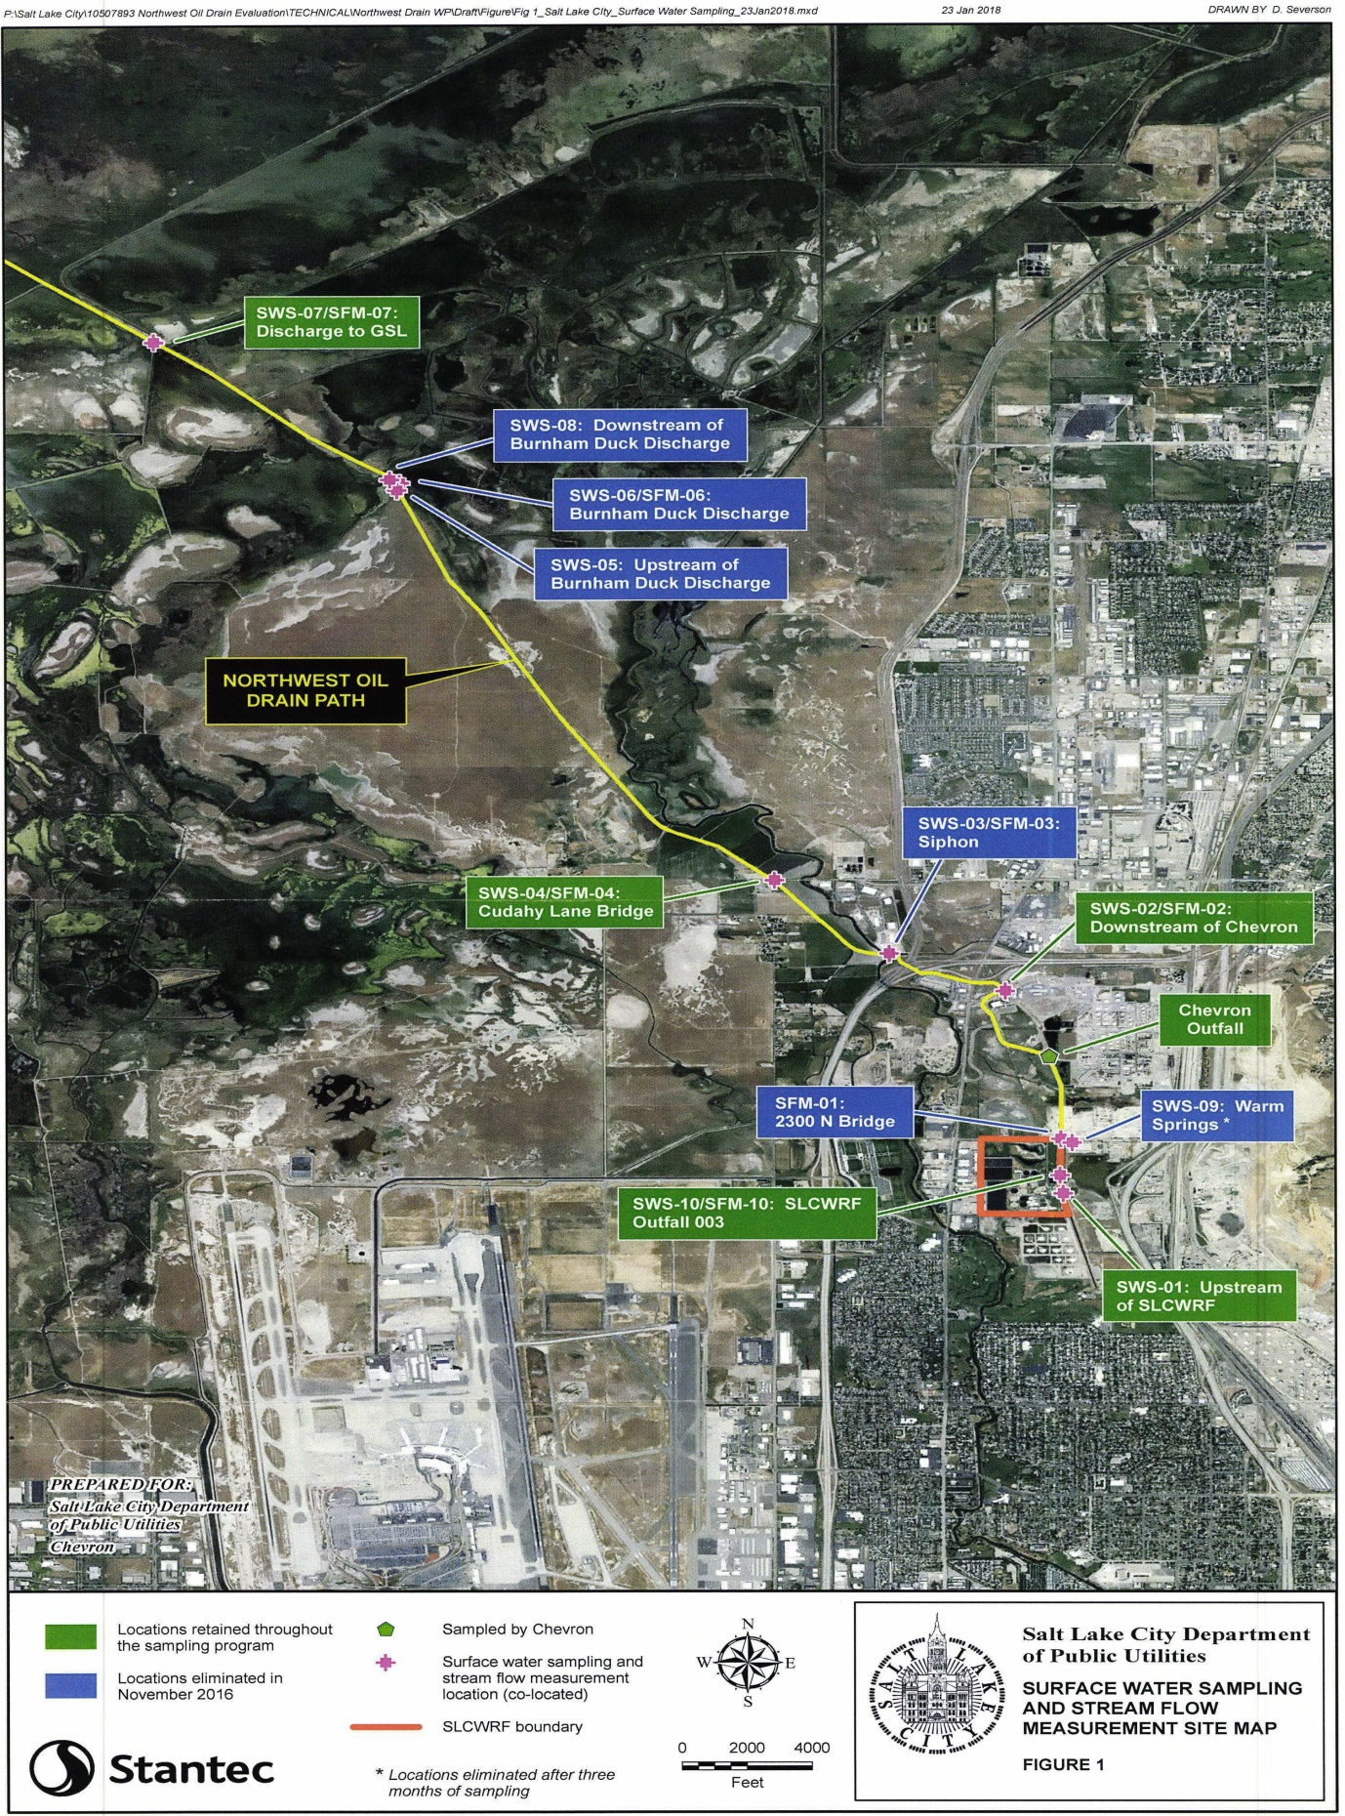

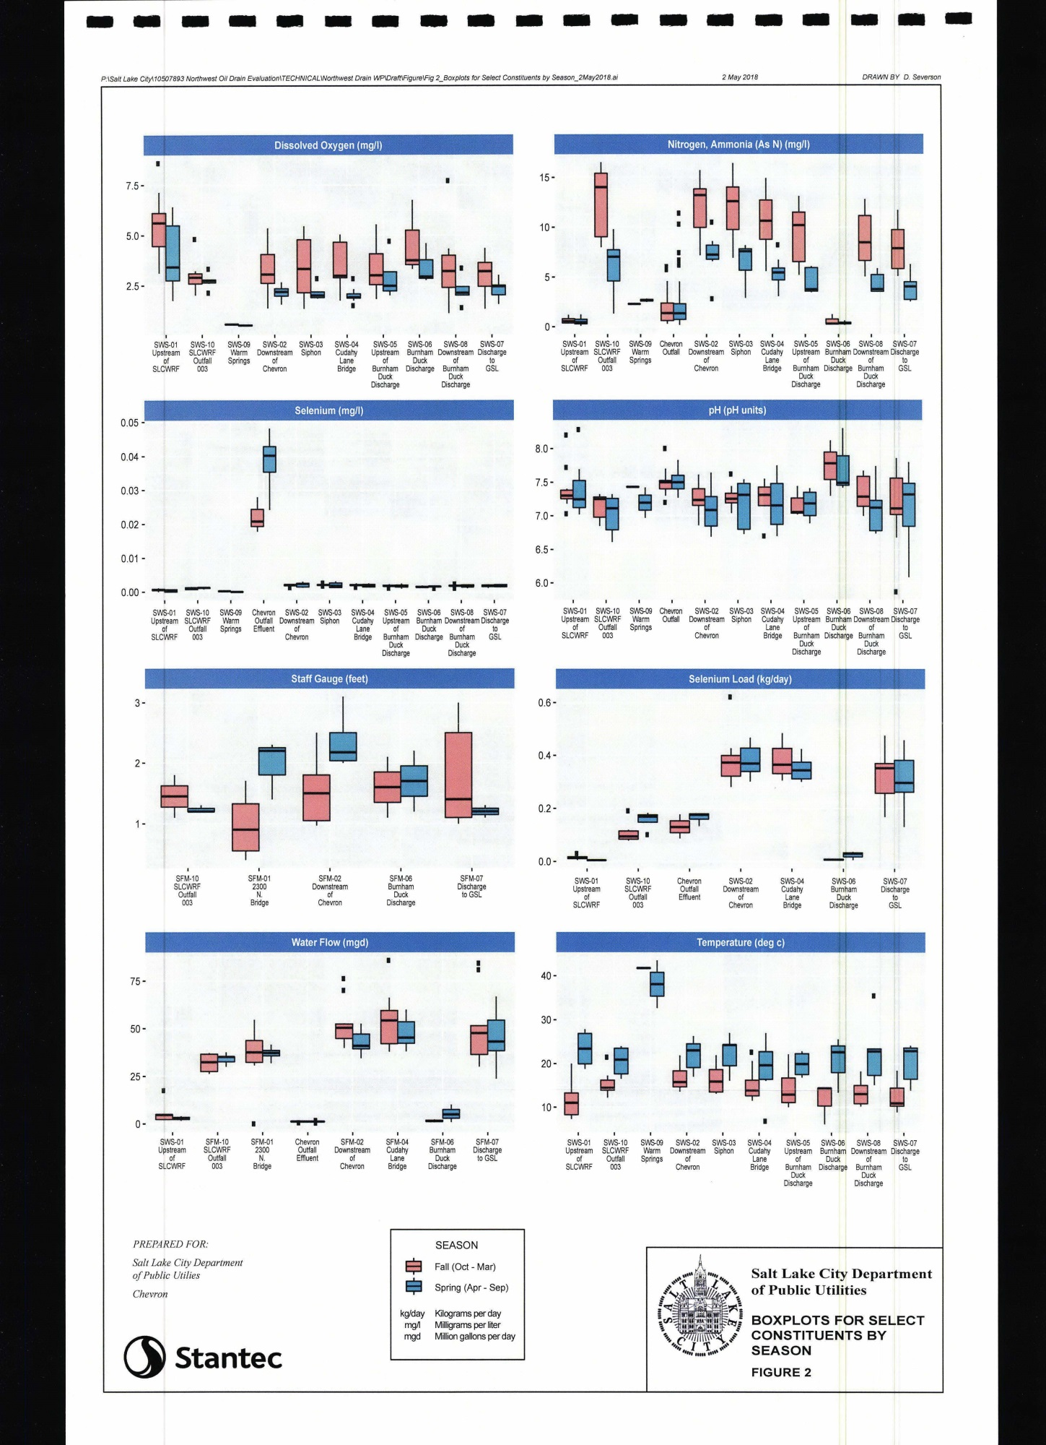

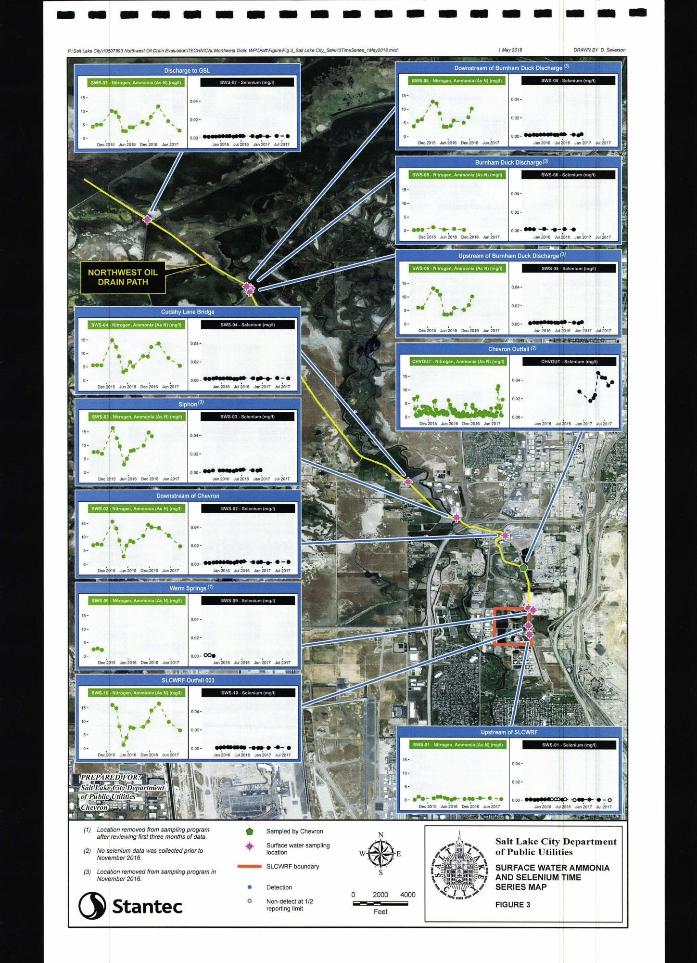

Figure 4. Ammonia concentrations in the Northwest Oil Drain compared to the 2013 EPA chronic ammonia criteria for no salmonids, unionids nor early life stages of fish. Values greater than 100% indicate exceedances.

Figure 5. Comparisons of Ammonia Loads measured at the NWOD discharge to Farmington Bay, the Salt Lake City Water Reclamation Facility and the Chevron Refinery

Figure 6. Summary of flow measurements from the NWOD Study (Stantec, 2018)

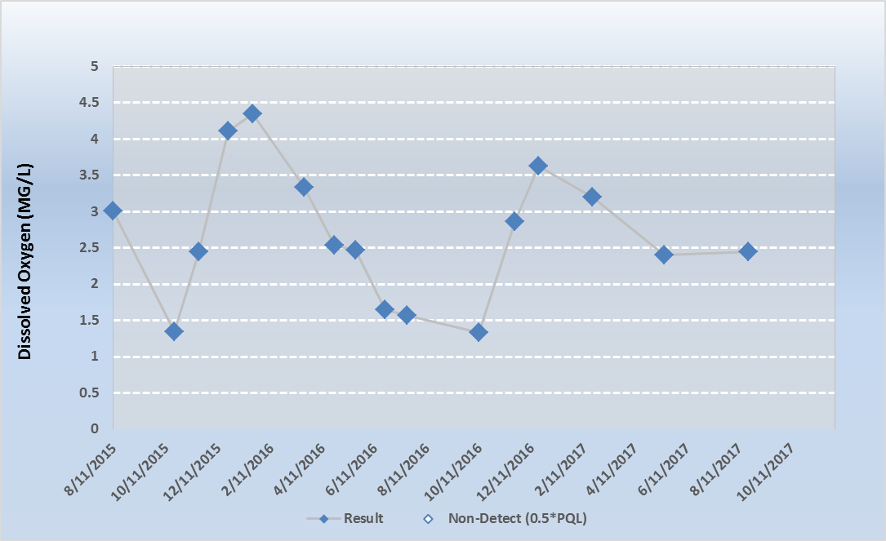

Figure 7. Dissolved oxygen concentrations measured in the NWOD at the discharge to Farmington Bay as part of the NWOD Study (Stantec, 2018)

https://documents.deq.utah.gov/water-quality/standards-technical-services/gsl-website-docs/alu-standards-development/DWQ-2019-000534.pdf

